**DAILY ONLINE ACTIVITIES SUMMARY**

|  |  |  |  |  |  |  |  |  |
| --- | --- | --- | --- | --- | --- | --- | --- | --- |
| **Date:** | **21-JULY-2020** | | | | | **Name:** | **RACHANA K N** | |
| **Sem & Sec** | **6th & B** | | | | | **USN:** | **4AL17CS070** | |
| **Online Test Summary** | | | | | | | | |
| **Subject** | | **-** | | | | | | |
| **Max. Marks** | | **-** | | **Score** | | | **-** | |
| **Certification Course Summary** | | | | | | | | |
| **Course** | **Advanced JAVA** | | | | | | | |
| **Certificate Provider** | | | **-** | | **Duration** | | | **2 hours** |
| **Coding Challenges** | | | | | | | | |
| **Status: Solved** | | | | | | | | |
| **Uploaded the report in Github** | | | | | **yes** | | | |
| **If yes Repository name** | | | | | **DAILY_STATUS** | | | |
| **Uploaded the report in slack** | | | | | **yes** | | | |

**ONLINE COURSE**

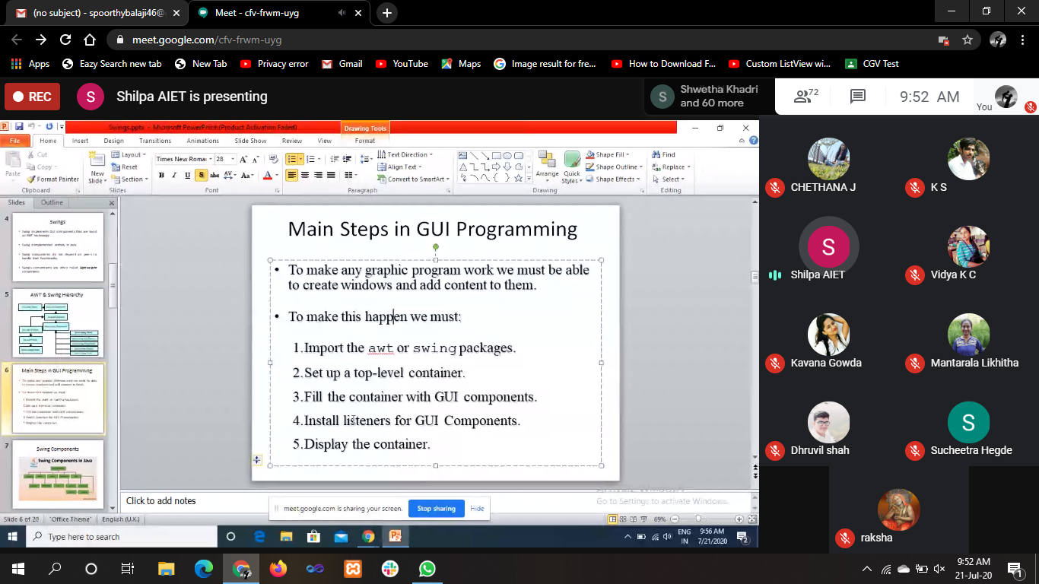

**Webinar on: “Agile Technologies”**



**ONLINE CODING**

**Python Program for GCD of more than two (or array) numbers**

def findgcd(x, y):

while(y):

x, y = y, x % y

return x

l = [22, 44, 66, 88, 94]

num1=l[0]

num2=l[1]

gcd=findgcd(num1,num2)

for i in range(2,len(l)):

gcd=findgcd(gcd,l[i])

print("gcd is: ",gcd)

